|  |
| --- |
|  |

Packet Capture Analysis:

Upon analyzing the packet capture analysis file (pcap) using Wireshark, I was able to produce the steps that the user used to access the following:

First, in Wireshark, I filtered the pcap to show only “http” requests from the network traffic to optimize my workflow. By doing this I was able to get a clear view of the conversation between the user and the server. This view of the conversation let me see some interesting GET requests that were performed by the user, indicating what the user was specifically requesting.   
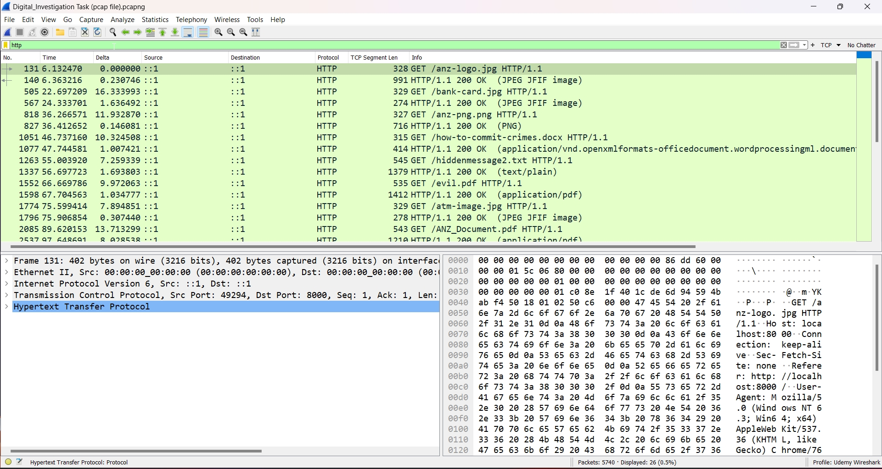  
So now we will follow these http streams from beginning to end and see what we come up with.

**Sub-task 1:**

* anz-logo.jpg and bank-card.jpg are two images that show up in the users' network traffic*.*

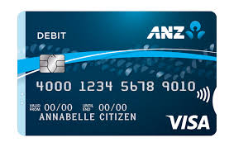

To extract these two images that the user accessed, I followed this procedure: Right click on the first GET request and followed the TCP stream like so.

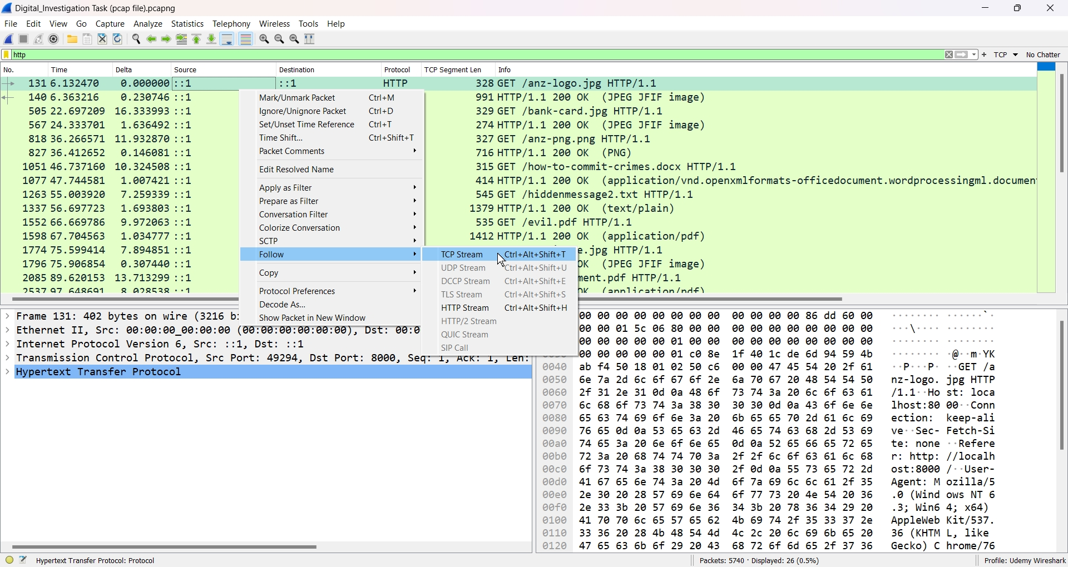

From here, I want to see the data in its raw form. So we can change the stream to Raw inside Wireshark like this:

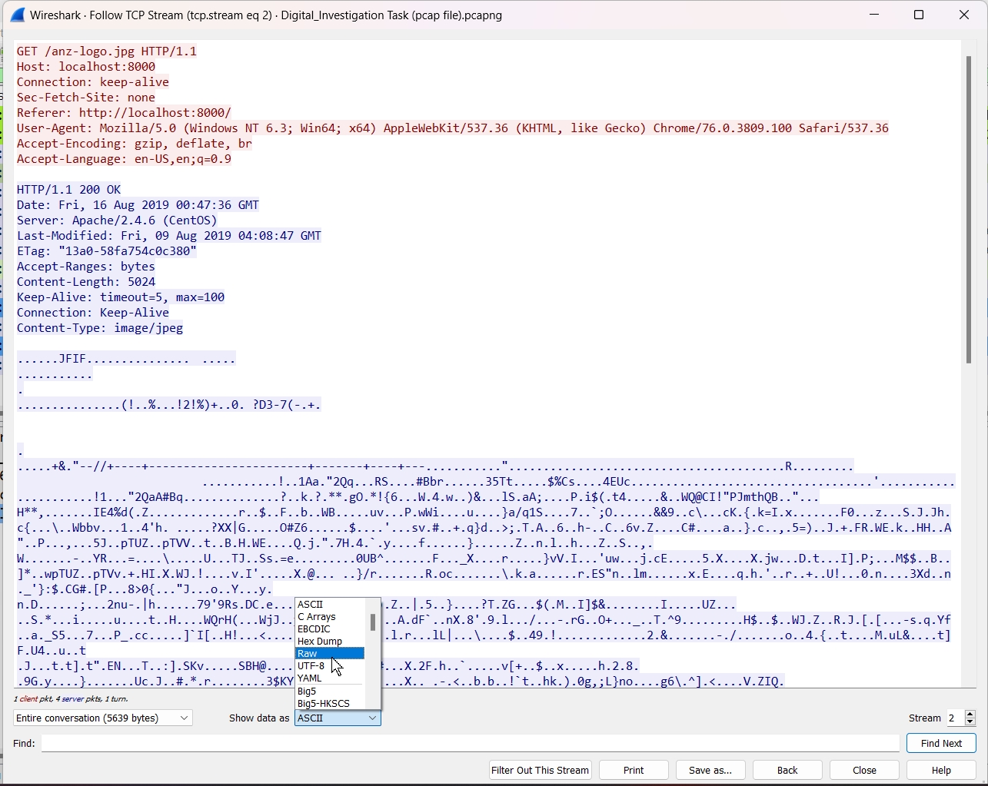

Now we want to search for the hex signature of the file. A simple google search for file hex signatures will help you with this, but for simplicity I will tell you about JPG hex signatures. They start with the hex numbers of “ffd8” and end with “ffd9”. Inside inside the Find bar, search for “ffd8” to find the beginning to the file signature.

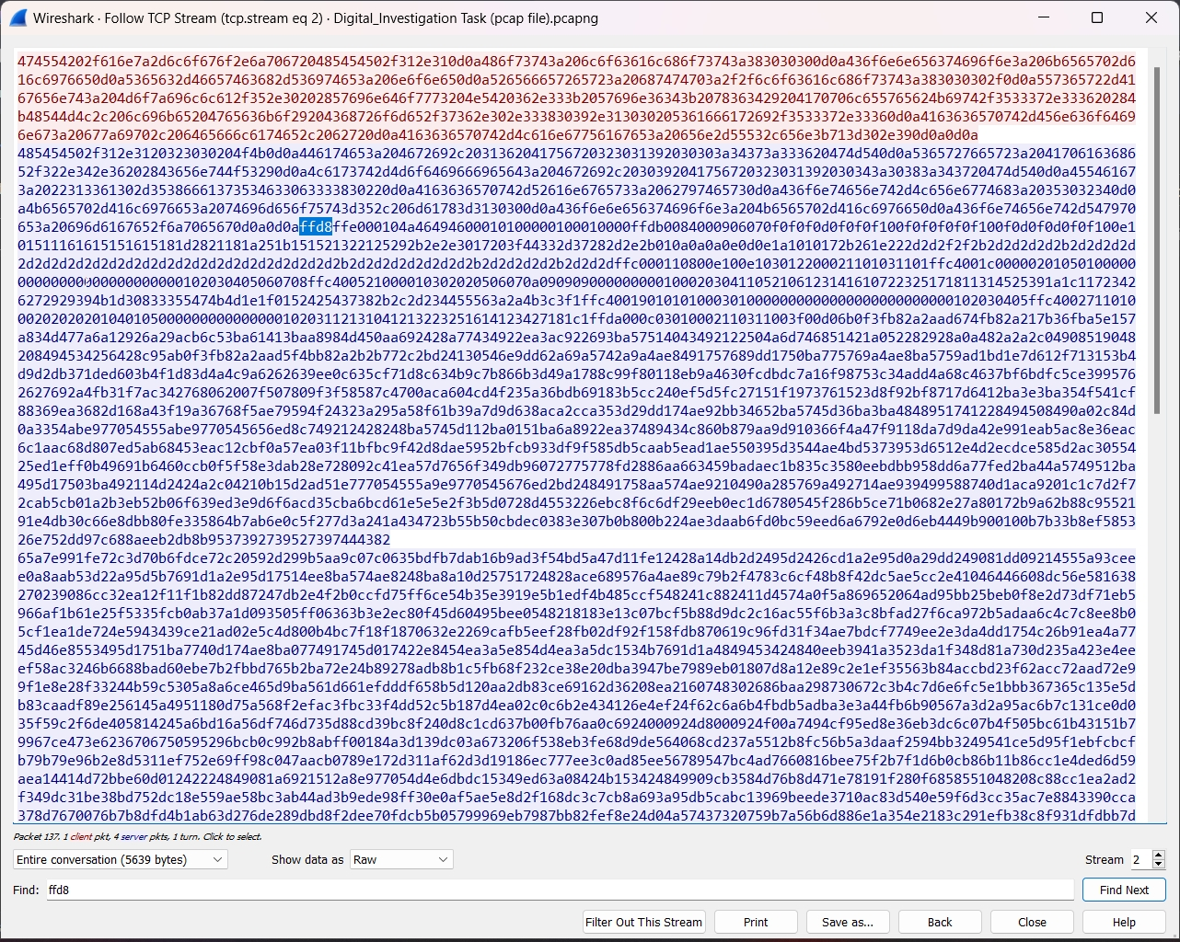

Now search for the end of the file signature “ffd9”, after find the end of the file signature, copy everything between the two points. This process is called File carving or Hex editing. We will now open up HxD editor, this is an application that can be used to edit hex. Click on new file, and binary options type. Then paste the raw data that we copied from Wireshark and save the file as a jpg extension type. The file will convert to a jpg extension and we can open it in a photo viewer to see its contents.

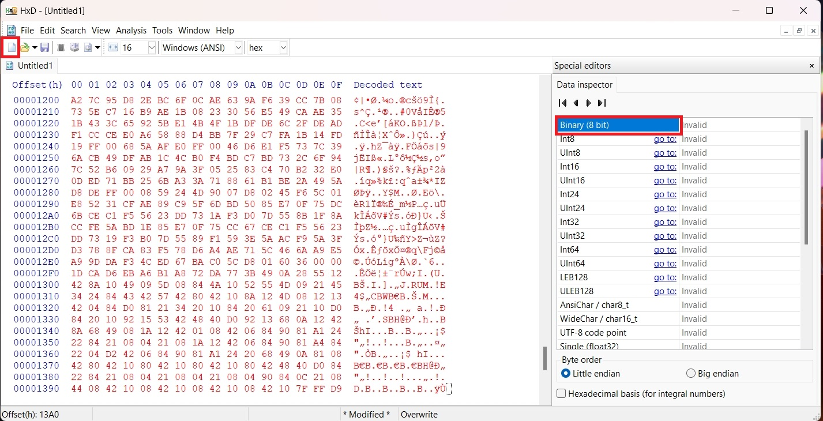

**Sub-task 2:**

* The network traffic for the images "ANZ1.jpg" and "ANZ2.jpg" is more than it appears.

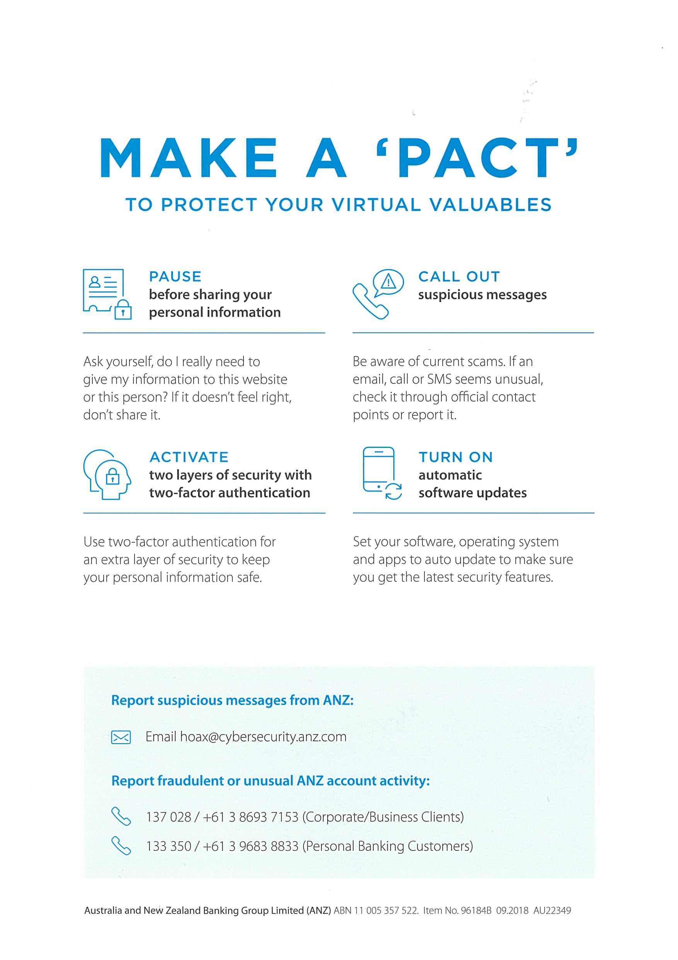

I extracted these images also following the same procedure as mentioned above. But I also noticed that there is something very unique about both images. They contained a hidden message.

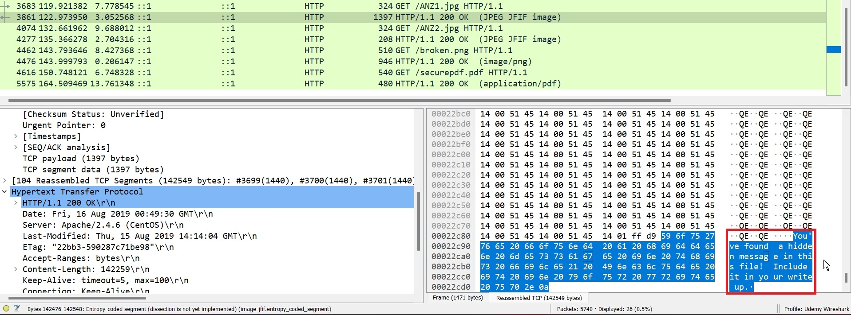

Both messages were found by this simple method.

**Sub-task 3:**

* The user downloaded a suspicious document called "how-to-commit-crimes.docx"

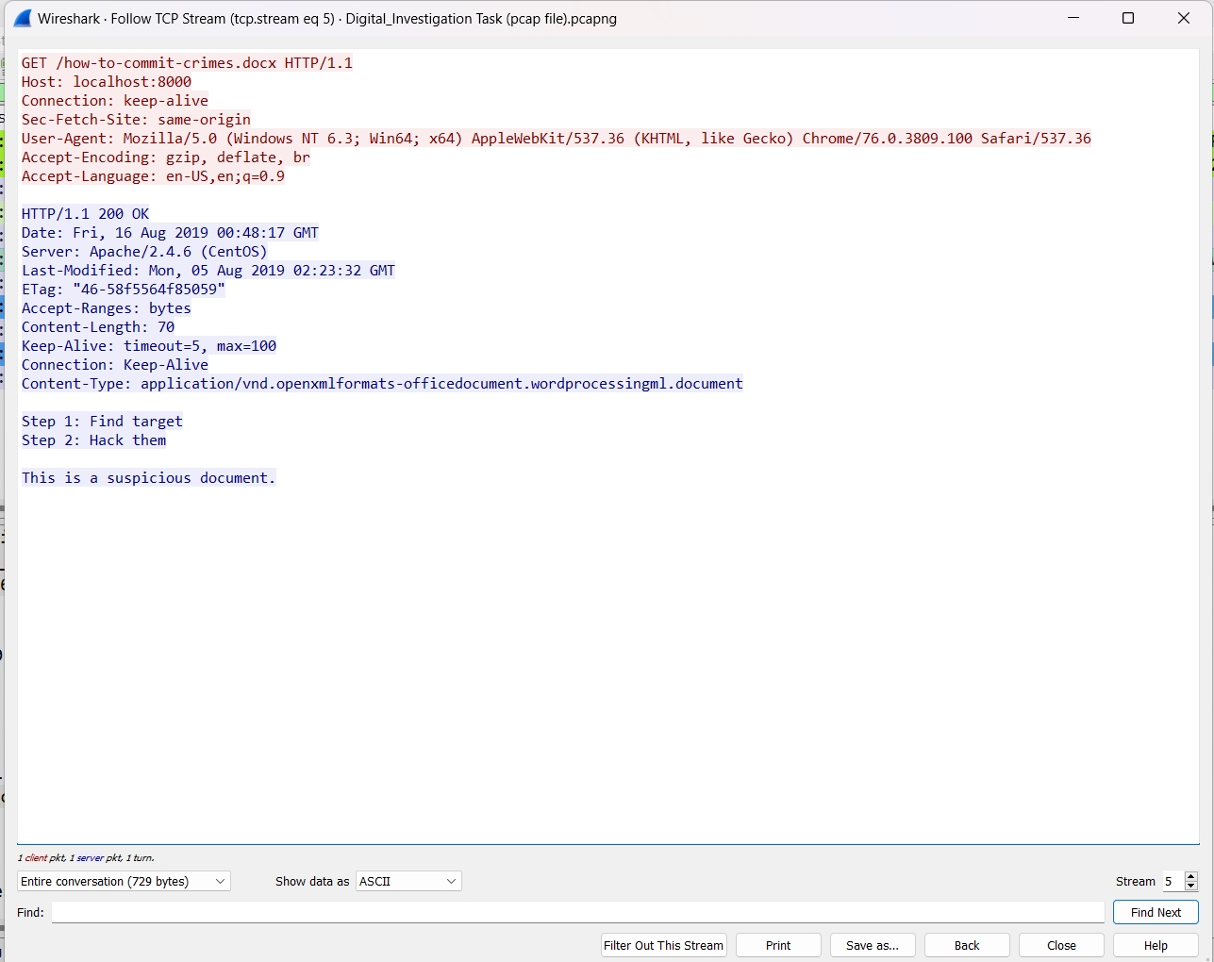

Seeing the user accessed this document, I followed the TCP stream and seen in the ascii view the contents of the document without having to edit the hex data.

**Sub-task 4:**

* The user accessed 3 pdf documents: ANZ_Document.pdf, ANZ_Document2.pdf, evil.pdf



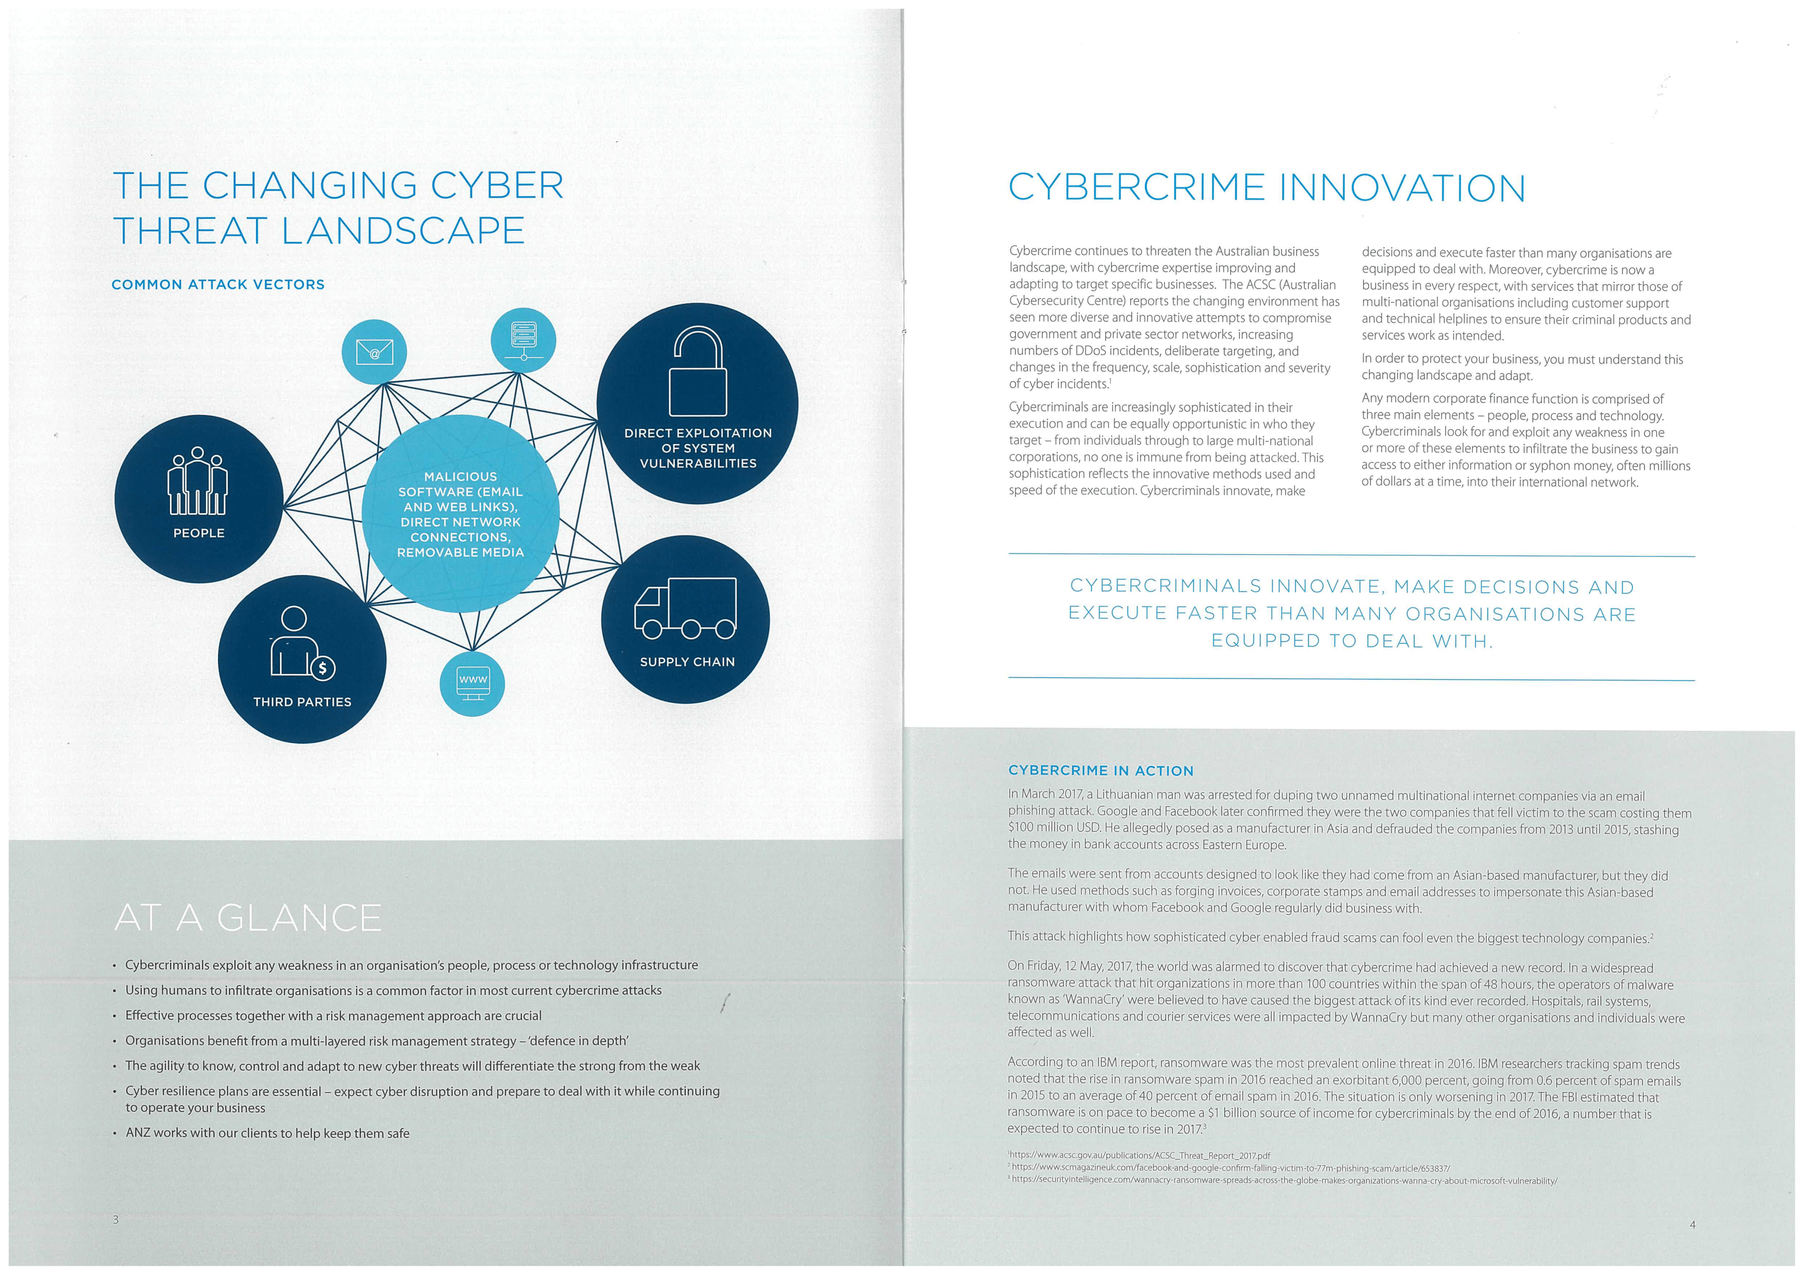

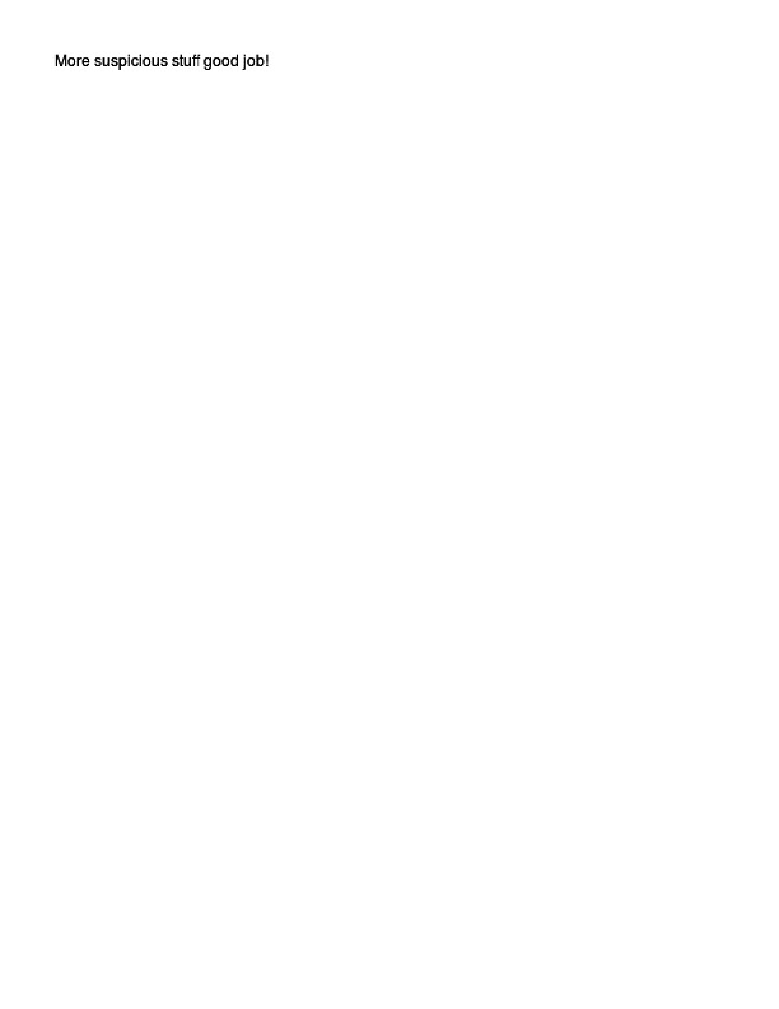

To extract these documents, the process is almost the same as doing it for jpg extensions, except for a few things done differently. We will go through this process. Follow the tcp stream like normal and go back to our google search “on file hex signatures and now we want to find out the hex signature for pdf documents. The hex signature is “255044462d” for pdf documents. We will search for this in the TCP stream and then once located, copy the contents of the raw data to the end of the stream and paste it in the HxD editor and save the file as a pdf file to view its contents.

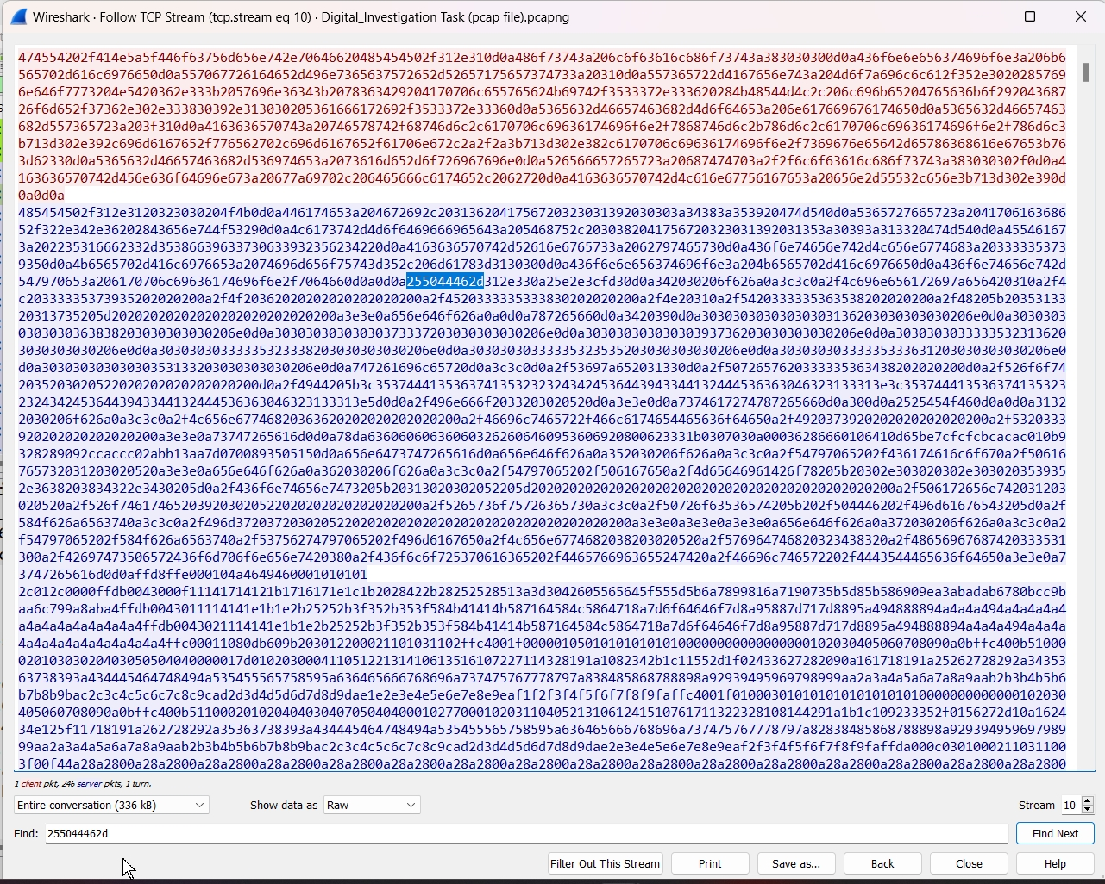

**Sub-task 5:**

* The user also accessed a file called "hiddenmessage2.txt"



Upon further analyzing this request, the user accessed a document called hiddenmessage.txt. But once I followed the TCP stream, searching for a txt signature did not work, but if we search for a jpg extension file signature of “ffd8”, we can carve out this image.

**Sub-task 6:**

* The user accessed an image called "atm-image.jpg"

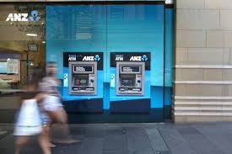

When I followed this TCP stream, I noticed that there are actually two images in this raw stream. Upon searching for “ffd8” it shows up in 2 different spots in the raw data. So, I found the beginning and end of the first picture and pasted it into HxD editor, and then did the same for the second image and this is what I came up with. A single GET request had downloaded both of these images.

**Sub-task 7:**

* The network traffic shows that the user accessed the image "broken.png"



To find this image, I first followed the TCP stream, then searched for its file signature and then copied it into HxD editor to extract this image.

**Sub-task 8:**

* The user accessed one more document called securepdf.pdf

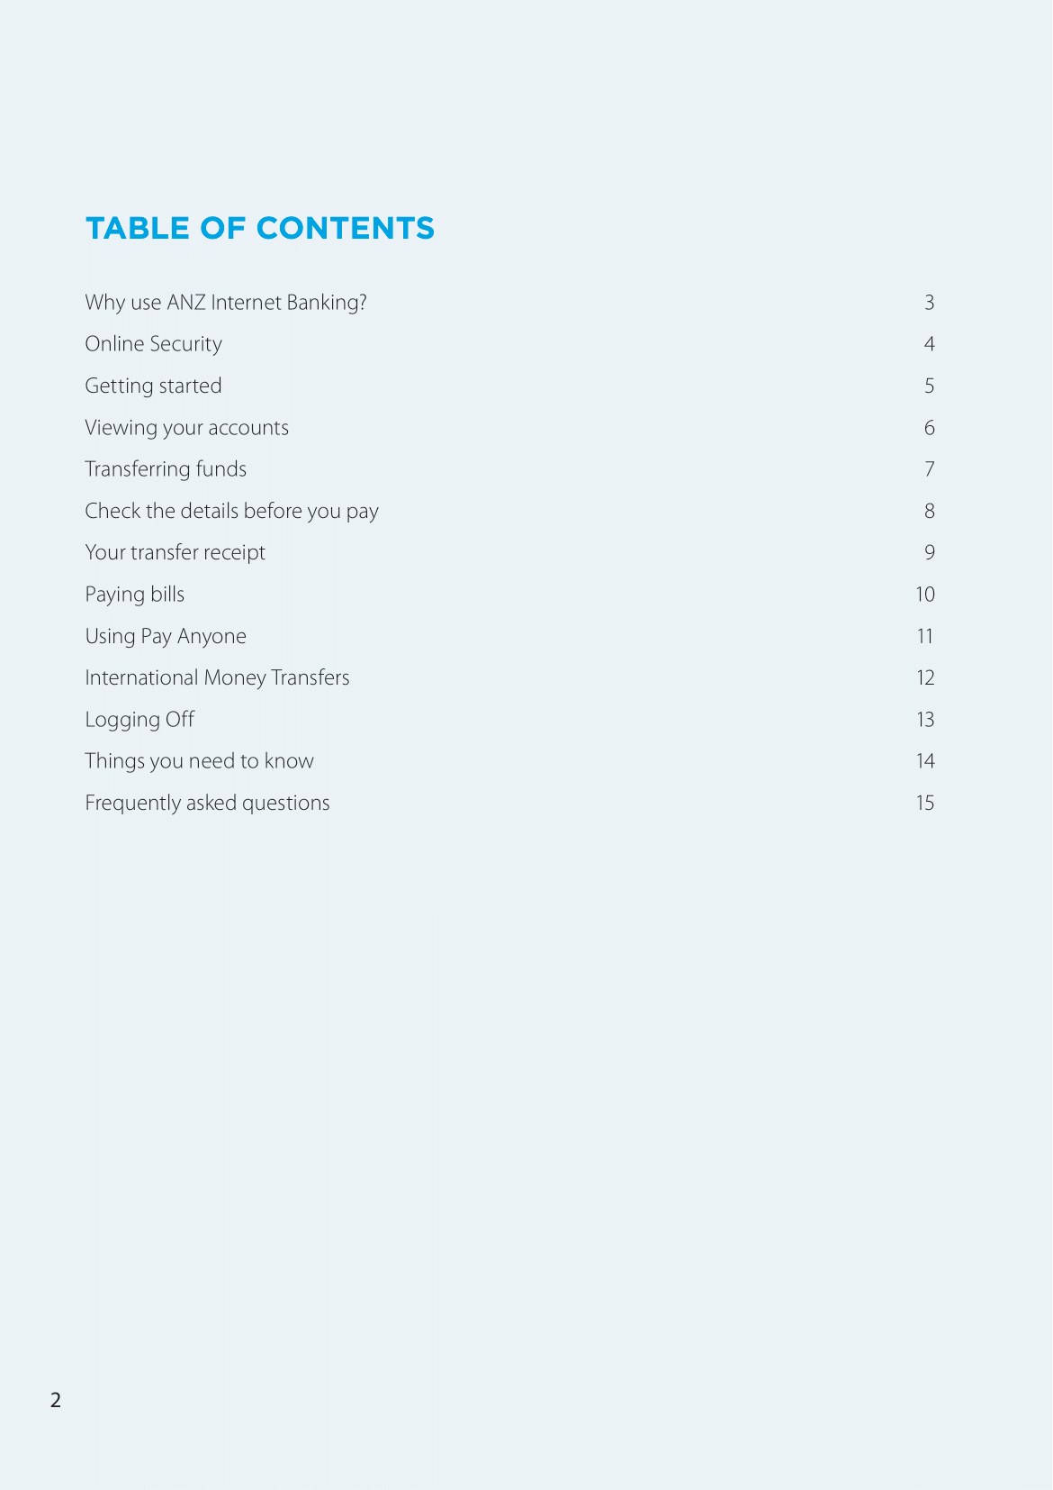

The user had accessed one more document called securepdf. Upon analyzing the TCP stream I had noticed that is was not a pdf file but rather a zip file. At the bottom of the ascii view, you can see that it says Password is “secure”.

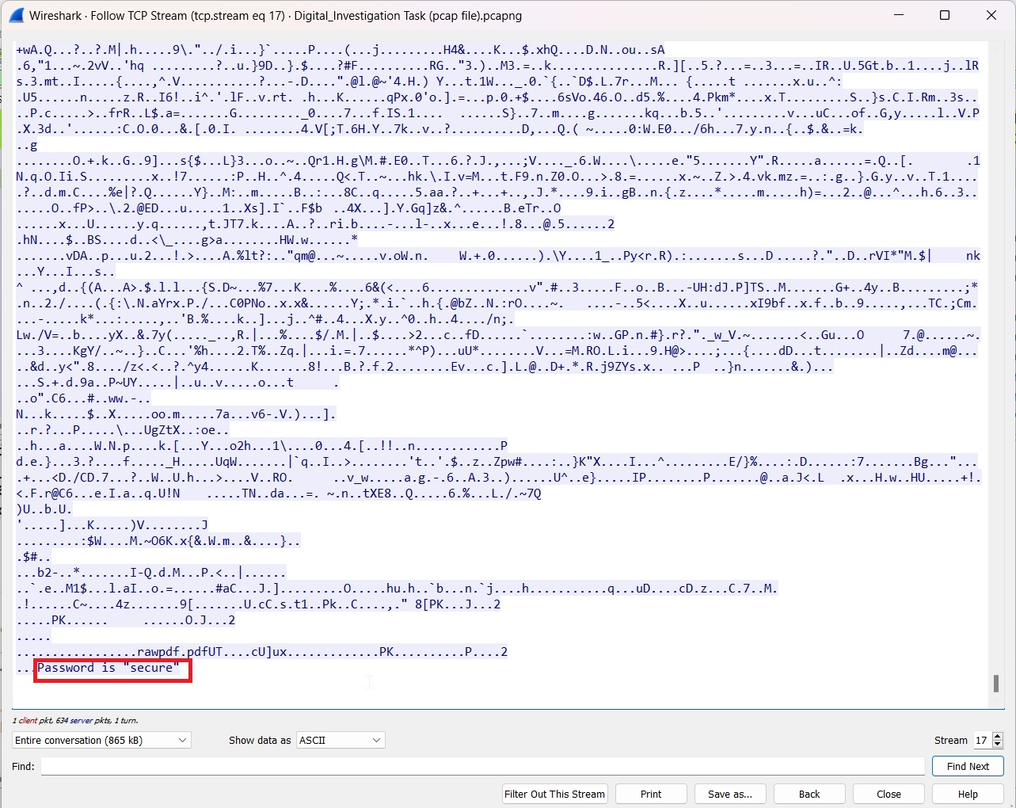

After seeing this, I found the file signature for zip files, search for the extension in the raw view and copied everything from the beginning of the signature to the end of the stream and pasted it into HxD editor, saving the file as a zip file. Then I extracted the zip file to get the document above. Indeed, when extracting it; it did ask me for the password, I entered “secure”, and it extracted the contents of the zip file. It was the first two pages of a guide for internet banking.